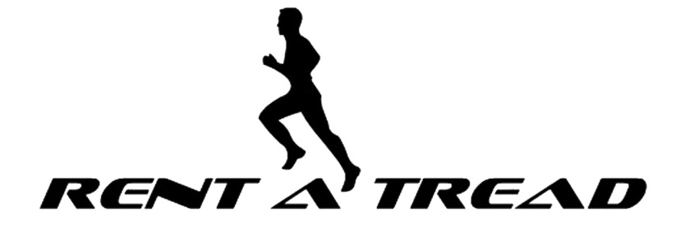

Rental Waiver and Agreement Form

Renter’s Name:______________________________ Age: _____

Address:________________________________ City: _________________State: _____ Zip: _________

Phone #: ___________________
E-Mail Address: ___________________________________________

EQUIPMENT RENTAL & LIABILITY RELEASE AGREEMENT:
I agree to accept for use AS IS all equipment to be provided during the multi-month program, and I agree to accept full financial responsibility for the care of the equipment while it is in the user’s possession. I will be responsible for the replacement at full value of any equipment provided under this form, but not returned to the Rent A Tread.

I understand that the equipment safety stop system cannot guarantee the user’s safety. During equipment use the safety stop may not prevent injury or death, nor is it possible to predict every situation in which it will stop. I agree to assume responsibility for any and all use of the rental equipment during the period of this rental agreement. I understand that handling heavy fitness equipment may cause serious injury. I agree to assume responsibility for anyone injured in either the use of our handling of this rental equipment during the period of this rental agreement.

I understand that the use of fitness equipment involves inherent and other risks of INJURY and possibly DEATH. I voluntarily agree to expressly assume all risks of injury or death that may result from using or handling Rent A Tread fitness equipment.

I understand that I should consult a physician before using any fitness equipment to ensure my fitness level is appropriate for all fitness activities including activities using fitness equipment. I recognize that serious injury or death can result even after I consult a physician.

I AGREE TO RELEASE AND HOLD HARMLESS the Rent A Tread LLC, its owners of the equipment and their successors in interest (collectively PROVIDERS) from all liability for injury, death, property loss and damage which results from the equipment users participation in the use of the rented fitness equipment, participation in this multi-month program, or is in any way related to the use of the equipment, including all liability that results from the NEGLIGENCE OF PROVIDERS, or any other person or cause.

I further agree to defend and indemnify PROVIDERS for any loss or damage, including any that results from claims or lawsuits for personal injury, death, and property loss and damage related in any way to the use of the equipment or participation in this multi-month program.

This agreement is governed by the applicable law of this state or province. If any provision of this agreement is determined to be unenforceable, all other provisions shall be given full force and effect.

I, THE UNDERSIGNED, HAVE READ THIS ENTIRE AGREEMENT, THE OWNERS MANUAL, AND FULLY UNDERSTAND THIS EQUIPMENT RENTAL & LIABILITY RELEASE AGREEMENT.

Renters Signature: ___________________________________________________________ Date:_______________________
Emergency Phone Numbers: (Home):___________________________________ (Work):_________________________________

